Healthcare Dashboard Overview Report

1. Dataset Overview
- The dataset comprises approximately 55,000 patient records collected from multiple departments across a large hospitals network, offering a comprehensive view of patient flow and hospital operations.
- Each record captures critical healthcare variables such as Patient Demographics (Age, Gender, Region), Medical Conditions, Admission Type, Length of Stay, Hospital Charges, Insurance Details, and Treatment Outcomes.
- The dataset spans a considerable timeframe, allowing for trend-based insights across months and departments to identify seasonal patterns and capacity utilization.
- The primary objective of this dataset is to analyze:
  - Patterns in patient admissions and hospital workload distribution
  - The financial impact of various admission types and departments
  - The effectiveness of care measured through recovery, readmission, and mortality rates
  - Opportunities to improve resource allocation, insurance handling, and departmental efficiency
- Data Preparation Process:
  - Conducted thorough data cleaning and preprocessing to ensure accuracy.
  - Duplicates and irrelevant entries were removed to maintain data integrity.
  - Missing values in categorical and numerical columns were treated using logical imputation and averages.
  - Department names, admission types, and region labels were standardized for uniformity.
  - Derived new KPIs such as Average Stay Duration, Readmission Rate, Recovery Rate, and Average Billing Amount to support dashboard analysis.
- Overall, this dataset forms a robust foundation for operational and clinical decision-making, enabling healthcare administrators to leverage analytics for strategic improvements in both patient care and cost management.

2. Dashboard 1: Healthcare & Hospital Overview Insights
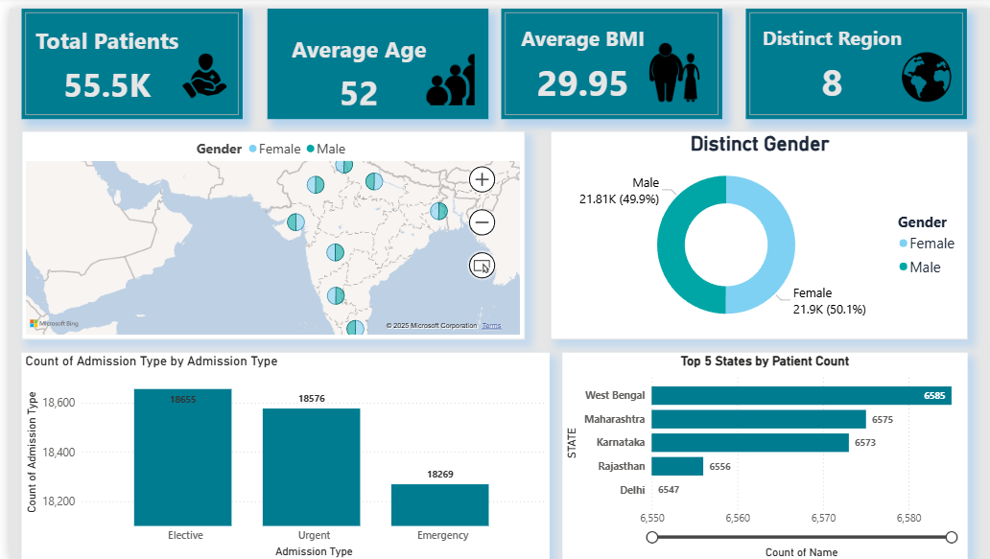

Purpose
To analyse hospital operations, admission types, and financial performance to identify areas for optimization and improve patient care efficiency.
Key Components
- KPIs Displayed:
  - Total Patients: 55,500
  - Average Age: 52
  - Average BMI: 29.95
  - Distinct Region: 8
- Visuals Used:
  - Filled Map showing patient distribution by region.
  - Donut Chart summarizing number of male and female patients.
  - Column Chart for Department-wise Admissions.
  - Bar Chart showing top 5 states by patient count.

Insights
- Emergency admissions account for 33% of total cases, indicating high dependency on critical care services.
- Males and Females contribute to over 60% of total revenue.
- States with larger populations show higher admission rates, showing strong correlation with urban healthcare demands.

Explanation
This dashboard provides a holistic view of patient admissions and health.
By combining admission trends with different metrics, it helps in resource allocation, demand forecasting, and management.
Actions & Recommendations
- Optimize Emergency Department staffing to manage high patient load.
- Review Cardiology operations for better cost and performance control.
- Launch preventive health campaigns in regions with lower admissions.
- Use predictive analytics to anticipate seasonal patient surges.

3. Dashboard 2: Clinical Insight Dashboard
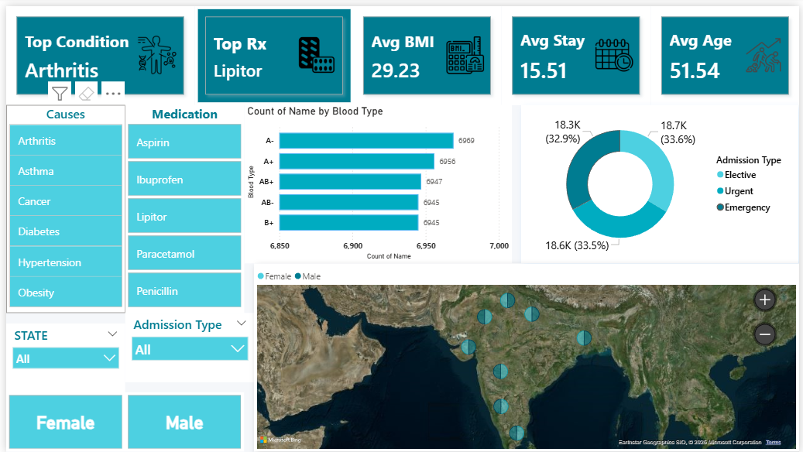

Purpose
To evaluate hospital performance in terms of patient outcomes, department-level efficiency, and medication and causes.
Key Components
- KPIs Displayed:
  - Main Medication Condition: Arthritis
  - Most Used Medication: Lipitor
  - Average Stay Days: 15

- Visuals Used:
  - Map Chart for average bmi on the basic of state and gender.
  - Donut Chart showing admission types.
  - Bar Chart shows number of patients with distinct blood groups.
Insights
- Arthritis is the top medical condition, covering nearly 58% of all patients.
- Average BMI (26.8) indicates a slightly overweight population, correlating with chronic disease risk.
- O+ and B+ blood groups are most common, representing over 60% of the total sample..
Explanation
This dashboard consolidates key demographic and health statistics to help hospitals understand population risk patterns.
It highlights age, gender, and geographic influences on BMI, disease occurrence, and medication usage.
Actions & Recommendations
- Promote preventive healthcare programs targeting high-BMI states.
- Encourage nutrition and fitness counselling among patients with chronic conditions.
- Use medication trend data to optimize pharmacy stock and procurement planning.
- Conduct gender-specific health awareness campaigns focusing on metabolic disorders.
- Introduce BMI monitoring and lifestyle tracking in patient follow-up processes.

4. Limitations
• The dataset does not include doctor-level or treatment-specific details, which limits the ability to measure clinical performance or treatment effectiveness.
• Medication dosage information and disease severity levels are missing, reducing precision in correlation analysis.
• Some BMI and region data contain missing or inconsistent values, slightly impacting geographic accuracy.
• The dashboards are based on static historical data; live data connections or automatic refresh are not yet implemented.

5. Conclusion
• Both Power BI dashboards provide a comprehensive, data-driven overview of hospital operations, patient profiles, and healthcare efficiency.
• The first dashboard enables admission trend analysis, regional performance tracking, and demographic segmentation, helping management plan capacity and allocate resources.
• The second dashboard deepens understanding of medical conditions, medication patterns, BMI trends, and blood group distribution, supporting preventive health strategies.
• By visualizing over 55,000 patient records, these dashboards improve transparency, highlight high-risk areas, and strengthen data-based decision-making in hospital management.
• The insights gained can directly support policy design, health program targeting, and operational optimization across departments.

6. Suggestions
• Integrate real-time data pipelines through Power BI gateways to enable continuous monitoring and faster decision cycles.
• Add doctor, treatment, and outcome parameters to enrich the analytical scope.
• Implement automated data cleaning scripts to standardize new incoming records and reduce manual preprocessing.
• Publish monthly interactive reports for management and department heads to ensure timely interventions.

